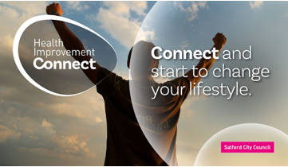

‘We Recover’
Long Covid Support Group

Have you been diagnosed with Long Covid?
Do you have ongoing symptoms of Long Covid?

If so, this group could be for you.

‘We Recover’ is a Long Covid Support Group that has been designed to help individuals make positive changes to promote wellbeing. We will provide you with tools and techniques, over a 6-week period, to support your road to recovery. This is a Council led service and there is no charge.

Sessions start
Thursday 30 September to 04 November
1.00pm to 2.30pm

The Poppy Day Centre
16-18 Worsley Road
Swinton M27 5WW

To book your place call the Health Improvement Team on 0800 952 1000 Option 2 or email health.improvement@salford.gov.uk ️

